# 1. Introduction

## 1.1 Generative Adversarial Networks (GANs)

Deep generative models have traditionally faced significant computational challenges in approximating probabilistic distributions and effectively leveraging neural network architectures. Generative Adversarial Networks (GANs) emerged as an innovative solution to these fundamental limitations. The core principle of GANs lies in a unique adversarial learning framework that fundamentally transforms generative modeling.

In the GAN framework, two neural networks engage in a competitive learning process:

* A generative model (G) that aims to capture the underlying data distribution
* A discriminative model (D) designed to distinguish between authentic training data and generated samples

This adversarial mechanism creates a dynamic training environment where both networks continuously refine their capabilities. The generator strives to produce increasingly convincing synthetic data, while the discriminator becomes progressively more sophisticated in detecting generated content.

## 1.2 Image Super-Resolution

Image super-resolution (SR) represents a critical image processing challenge that addresses the reconstruction of high-resolution images from low-resolution inputs. Traditional interpolation methods often produce suboptimal results, characterized by blurriness, artifacts, and loss of fine details. The field requires advanced techniques that can intelligently enhance image resolution while preserving perceptual quality and textural information.

The primary challenges in image super-resolution include:

* Maintaining perceptual realism
* Preserving fine-grained textural details
* Minimizing artifacts and distortions
* Generating visually compelling high-resolution outputs

## 1.3 SRGAN

The Super-Resolution Generative Adversarial Network (SRGAN) represents a groundbreaking approach to addressing image super-resolution limitations. Unlike traditional methods that rely on pixel-level mean squared error (MSE) optimization, SRGAN introduces a novel perceptual loss function that prioritizes visual quality and perceptual realism.

Key innovations of SRGAN include:

* A deep residual network architecture
* An adversarial training strategy
* A perceptual loss function combining adversarial and content losses
* Ability to generate visually sophisticated high-resolution images

This research explores the implementation and performance of SRGAN, investigating its architectural innovations, training methodology, and potential applications in advanced image reconstruction tasks.

# 2. Architecture

## 2.1 Adversarial Network Architecture

The SRGAN architecture comprises two primary neural networks: a deep residual network generator and a discriminator network, each designed to address specific challenges in high-quality image super-resolution.

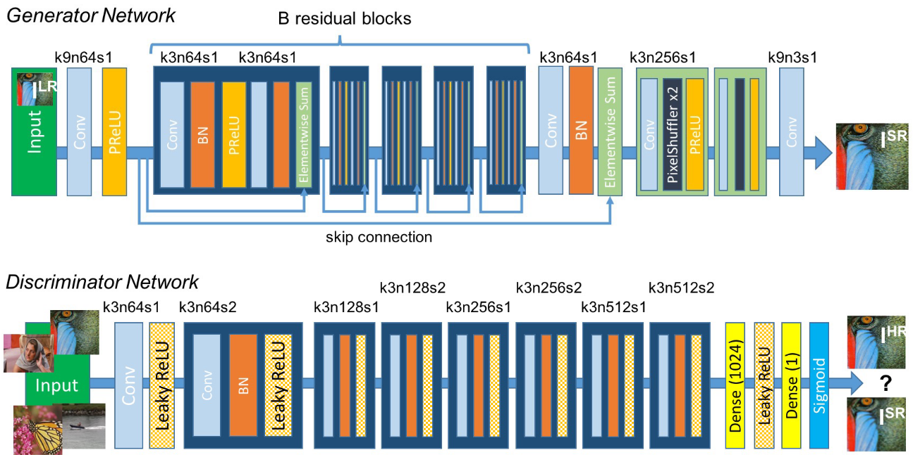

A discriminator network $D_{θ_{D}}$ is optimize with $G_{θ_{G}}$ in an alternating manner to solve the adversarial min-max problem:

$$\min_{θ_{G}}{\max_{θ_{D}}{E_{I^{HR}\sim p_{train}\left(I^{HR}\right)}\left[\log{D_{θ_{D}}\left(I^{HR}\right)}\right]+E_{I^{LR}\sim P_{G}\left(I^{LR}\right)}\left[\log\left(1-D_{θ_{D}}\left(G_{θ_{G}}\left(I^{LR}\right)\right)\right)\right]}}$$

### 2.1.1 Generator Network

The generator network employs a deep residual architecture optimized for image upscaling. Key characteristics include:

* Utilization of residual blocks with parametric ReLU activation
* Convolutional layers with stride and kernel configurations designed for efficient feature extraction
* Pixel shuffle layers for upsampling, replacing traditional transposed convolution
* Network depth optimized to capture multi-scale image features

The generator's primary objective is to transform low-resolution input images into high-resolution outputs that are perceptually indistinguishable from ground truth images.

### 2.1.2 Discriminator Network

The discriminator network functions as a binary classifier with the following architectural principles:

* Convolutional layers progressively increasing in depth
* Batch normalization to stabilize feature learning
* Leaky ReLU activation functions
* Fully connected layers for final classification

The discriminator's role is to distinguish between authentic high-resolution images and generated super-resolved images, providing critical feedback to the generator during adversarial training.

## 2.2 Perceptual Loss Function

SRGAN introduces a novel perceptual loss function that fundamentally differs from traditional pixel-wise loss metrics. The loss function is formulated as:

$$l^{SR}=\underset{perceptual loss (for VGG based content losses)}{\underbrace{\underset{content loss}{\underbrace{l_{X}^{SR}}}+\underset{adversarial loss}{\underbrace{{10}^{-3}l_{Gen}^{SR}}}+\underset{total variation loss}{\underbrace{{2.10}^{-8}l_{TV}^{SR}}}}}$$

### Content Loss

The content loss comprises two primary components:

* Pixel-wise Mean Squared Error (MSE):
$$l_{MSE}^{SR}=\frac{1}{r^{2}WH}\sum_{x=1}^{rW}{\sum_{y=1}^{rH}{{\left(I_{x,y}^{HR}-G_{θ_{G}}{\left(I^{LR}\right)}_{x,y}\right)}^{2}}}$$

* Perceptual loss derived from pre-trained VGG16:

$$l_{VGG/i.j}^{SR}=\frac{1}{W_{i,j}H_{i,j}}\sum_{x=1}^{W_{i,j}}{\sum_{y=1}^{H_{i,j}}{{\left(ϕ_{i,j}{\left(I^{HR}\right)}_{x,y}-ϕ_{i,j}{\left(G_{θ_{G}}\left(I^{HR}\right) \right)}_{x,y}\right)}^{2}}}$$

$$where \left\{ϕ_{i,j}=feature map of j^{th} convolution \left(after activation\right) before i^{th} maxpool layer\right.$$

The perceptual loss leverages feature representations from intermediate convolutional layers, capturing high-level image characteristics beyond pixel-level differences.

### 2.2.2 Adversarial Loss

The adversarial loss term, derived from the generator-discriminator interaction, encourages the generation of photorealistic images. It is formulated to maximize the probability of the generated image being classified as authentic by the discriminator, while minimize the generative loss defined as:

$$l_{Gen}^{SR}=\sum_{n=1}^{N}{-\log{D_{θ_{D}}\left(G_{θ_{G}}\left(I^{LR}\right) \right)}}$$

Here, $D_{θ_{D}}(G_{θ_{G}}\left(I^{LR}\right))$ is the probability that the reconstructed image $G_{θ_{G}}\left(I^{LR}\right)$ is a ground truth HR image. For better computation of gradient, they minimize $-\log{D_{θ_{D}}\left(G_{θ_{G}}\left(I^{LR}\right) \right)}$ instead of $\log\left[1-D_{θ_{D}}\left(G_{θ_{G}}\left(I^{LR}\right) \right)\right]$.

### Total Variation Loss

Total Variation Loss is a regularization technique that encourages spatial smoothness in an image by minimizing the differences between neighboring pixel intensities. It penalizes abrupt changes in pixel values, reducing noise while preserving edge structures. It is formulated as:

$$l_{TV}^{SR}=\frac{1}{HW}\sum_{i=0}^{H}{\sum_{j=0}^{W}{{\left({\left(x_{i+1,j}-x_{i,j}\right)}^{2}+{\left(x_{i,j+1}-x_{i,j}\right)}^{2}\right)}^{\frac{1}{2}}}}$$

# 3. Experiments and Evaluation

## 3.1 Training Details and Parameters

The super-resolution model was trained with these configuration parameters:

**Training Configuration**

| **Parameter** | **Value** | **Note** |
| --- | --- | --- |
| Learning Rate | 1e-4 |  |
| Training Epochs | 400 | Main training phase using VGG loss (enable discriminator) |
| Warmup Epochs | 10 | Initial training phase using MSE loss (disable discriminator) |
| Batch Size | 16 |  |
| Number of Workers | 4 |  |
| Upscaling Scale | 4x |  |
| HR Size | 96x96 |  |
| LR Size | 24x24 |  |

## 3.2 Evaluation Results

**Performance Comparison Across Datasets**

| **Dataset** | **PSNR** | **SSIM** | **LPIPS** | **MSE** |
| --- | --- | --- | --- | --- |
| SET5 | 0.00 | 0.00 | 0.00 | 0.00 |
| SET14 | 0.00 | 0.00 | 0.00 | 0.00 |
| BSD100 | 0.00 | 0.00 | 0.00 | 0.00 |
| URBAN100 | 0.00 | 0.00 | 0.00 | 0.00 |